AN INTRODUCTION TO ENGINEER

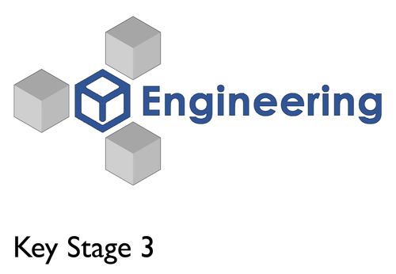 In 1961, the Conference of Engineering Societies of Western Europe and the United States of America defined "[professional engineer](https://en.wikipedia.org/wiki/Professional_engineer)" as follows:[[6]](https://en.wikipedia.org/wiki/Engineer#cite_note-6)

A professional engineer is competent by virtue of his/her fundamental education and training to apply the scientific method and outlook to the analysis and solution of engineering problems. He/she is able to assume personal responsibility for the development and application of engineering science and [knowledge](https://en.wikipedia.org/wiki/Knowledge), notably in research, design, construction, manufacturing, superintending, managing, and in the education of the engineer. His/her work is predominantly intellectual and varied and not of a routine mental or physical character. It requires the exercise of original thought and judgment and the ability to supervise the technical and administrative work of others. His/her education will have been such as to make him/her capable of closely and continuously following progress in his/her branch of engineering science by consulting newly published works on a worldwide basis, assimilating such [information](https://en.wikipedia.org/wiki/Information), and applying it independently. He/she is thus placed in a position to make contributions to the development of engineering science or its applications. His/her education and training will have been such that he/she will have acquired a broad and general appreciation of the engineering sciences as well as thorough insight into the special features of his/her own branch. In due time he/she will be able to give authoritative technical advice and assume responsibility for the direction of important tasks in his/her branch.



TYPES OF ENGINEER

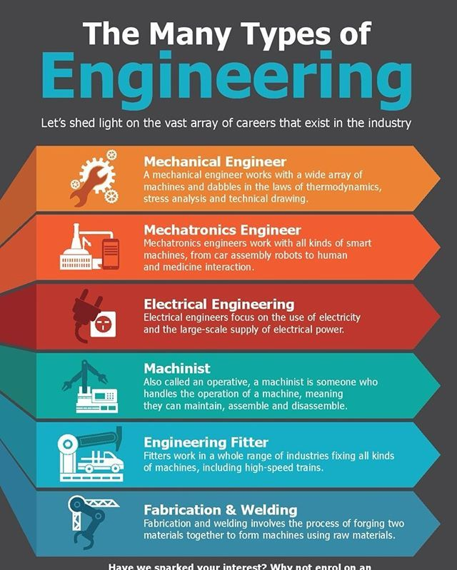



1. Mechanical Engineer: **Mechanical engineering** is the study of physical [machines](https://en.wikipedia.org/wiki/Machine) that may involve [force](https://en.wikipedia.org/wiki/Force) and movement. It is an [engineering branch](https://en.wikipedia.org/wiki/Engineering_branch) that combines [engineering physics](https://en.wikipedia.org/wiki/Engineering_physics) and [mathematics](https://en.wikipedia.org/wiki/Engineering_mathematics) principles with [materials science](https://en.wikipedia.org/wiki/Materials_science), to [design](https://en.wikipedia.org/wiki/Design), analyze, manufacture, and maintain [mechanical systems](https://en.wikipedia.org/wiki/Mechanical_system).[[1]](https://en.wikipedia.org/wiki/Mechanical_engineering#cite_note-1) It is one of the oldest and broadest of the [engineering branches](https://en.wikipedia.org/wiki/List_of_engineering_branches).
2. Mechatronic Engineer: A mechatronics engineer specializes in the integrated design and development of intelligent systems that merge mechanical engineering, electronics, computer science, and control engineering. The term "mechatronics" is derived from the combination of "mechanics" and "electronics," emphasizing the interdisciplinary nature.
3. Electrical engineer: Electrical engineering is an engineering discipline concerned with the study, design, and application of equipment, devices, and systems which use electricity, electronics, and electromagnetism.
4. 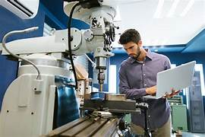 Machinist engineer: machining engineer designs and develops manufacturing processes for metal parts using a variety of tools, machines, and software programs. They work with other engineers to determine the most effective methods for producing high-quality parts while minimizing waste and reducing costs.

5. Welding engineer: In short, a welding engineer is a professional who specializes in the design, development, and implementation of welding processes and systems. Welding engineers play a critical role in ensuring the safety, reliability, and efficiency of various industrial applications.

## Engineering functions

[](https://cdn.britannica.com/90/177790-050-16499617/geothermal-energy-Iceland.jpg)

[geothermal energy](https://cdn.britannica.com/90/177790-050-16499617/geothermal-energy-Iceland.jpg)

Problem solving is common to all engineering work. The problem may involve quantitative or qualitative factors; it may be physical or economic; it may require abstract mathematics or common sense. Of great importance is the process of [creative](https://www.britannica.com/dictionary/creative) synthesis or design, putting ideas together to create a new and optimum solution.

Although engineering problems vary in scope and complexity, the same general approach is applicable. First comes an analysis of the situation and a preliminary decision on a plan of attack. In line with this plan, the problem is reduced to a more categorical question that can be clearly stated. The stated question is then answered by [deductive reasoning](https://www.britannica.com/topic/deduction-reason) from known principles or by creative synthesis, as in a new design. The answer or design is always checked for accuracy and adequacy. Finally, the results for the simplified problem are interpreted in terms of the original problem and reported in an [appropriate](https://www.britannica.com/dictionary/appropriate) form.

Problem solving is common to all engineering work. The problem may involve quantitative or qualitative factors; it may be physical or economic; it may require abstract mathematics or common sense. Of great importance is the process of [creative](https://www.britannica.com/dictionary/creative) synthesis or design, putting ideas together to create a new and optimum solution.

Although engineering problems vary in scope and complexity, the same general approach is applicable. First comes an analysis of the situation and a preliminary decision on a plan of attack. In line with this plan, the problem is reduced to a more categorical question that can be clearly stated. The stated question is then answered by [deductive reasoning](https://www.britannica.com/topic/deduction-reason) from known principles or by creative synthesis, as in a new design. The answer or design is always checked for accuracy and adequacy. Finally, the results for the simplified problem are interpreted in terms of the original problem and reported in an [appropriate](https://www.britannica.com/dictionary/appropriate) form.